Company Overview:

ABC Vintage Store:
- Website URL: https://www.abcvintagestore.com/ (hypothetical).
- Store location in the United States: Fort Worth, Texas.
- ABC Vintage Store is a small, family-owned business specializing in vintage records, collectibles, and retro merchandise. Established in the mid-2010s, the store has grown into a beloved local destination for music enthusiasts and collectors.
- Its retail space offers a wide assortment of vinyl, CDs, cassettes, and vintage items such as posters, apparel, magazines, and memorabilia.
- The company generates revenue through both in-store and online sales, combining a nostalgic shopping experience with a convenient e-commerce platform.
- ABC Vintage Store uses a click-and-mortar approach to reach customers beyond its physical location.
- As part of this project, our team proposed a cloud-based inventory management system that tracks stock movement in real time and synchronizes product availability between the store and its website. This modernization would improve data accuracy, reduce manual errors, and enhance customer satisfaction.
SWOT Analysis:

- Strengths:
  - Spacious retail area that accommodates a large and diverse product inventory.
  - Online store offers a wide range of records, CDs, and vintage merchandise.
  - Strong local reputation for carrying rare and unique collectibles.
  - Online store provides information on whether an item is available in store.
- Weaknesses:
  - Unavailable items are presented on online store pages.
  - Certain website sections labeled for specialty stock are incomplete or missing listings.
  - Lack of a structured customer feedback and preference-tracking system limits marketing insight.
- Opportunities:
  - Implementation of Customer Relationship Management to track what customers like and do not like about the store, its service, and its products.
    - Can send out advertising emails to customers in the database on new items when brought into the store based on previous customer purchases and preferences.
  - Expand the online catalog to include all specialty and vintage stock.
- Threats:
  - Competing vintage and record retailers within the broader local market.
  - Online resale platforms that offer similar items at variable prices, such as Poshmark and eBay.
  - Potential loss of customers if inventory data between the online store and physical location remain unsynchronized.
  - Customer dissatisfaction due to incomplete or outdated online listings.

Type of Business Issue Addressed in the Project:

ABC Vintage Store, a local buy and sell store that specializes in physical media and other miscellaneous vintage products, has an underdeveloped inventory tracking system that constricts the amount of information shared with customers. Furthermore, this system also impairs the performance of the company and could be impacting how the business interacts with their customers. Although ABC Vintage Store is easy to contact based on the information provided on their website, implementing a more modern inventory system could save valuable time for the employees. With this information in mind, the main pain-point that we will focus on is the underdeveloped inventory management system and process. We believe that addressing this issue will lead to better performance and improved service.

A systems request for better performance is made when the current system being used fails to meet the business's performance requirements. By implementing a cloud-based inventory management system, we can streamline the process and allow for real-time stock updates. This will reduce manual errors, ensure product availability, and improve operational efficiency.

Similarly, a systems request for improved service is made when improvements are necessary in the customer service department of a company. Issues that customers may have with unavailable items being listed online can lead to dissatisfaction and loss of sales. Introducing a CRM system will enable ABC Vintage Store to track customer preferences, gather feedback, and improve marketing efforts.

Description of the Current Operation Related to the Key Business Issue:

One key pain-point that currently exists within ABC Vintage Store is their underdeveloped inventory management system and process, which is preventing them from providing customers with real-time information about their store online. It appears that they presently use a manual way of tracking their inventory that is not easily transferable to their website. This system is inhibiting potential customers, who may not live close enough to shop in the store’s physical location, from enjoying the products of this store and contributing to the profits of this store. While some items on the website appear to be updated regularly, others clearly are not or are simply nonexistent. For example, their physical media, their most consistent product, has a constant presence on their website, and seems to be updated frequently. On the other hand, their vintage goods are labeled on their website, but when you click the link to view them, they are simply not uploaded onto the website. This may be due to a quick turnover with this particular type of inventory or because the company is lacking an efficient inventory tracking system that keeps customers updated on product availability. These inefficiencies result in bottlenecks such as delayed product updates on the website and potential errors in stock management.

This inventory issue is the root cause of the operational inefficiencies and customer dissatisfaction previously discussed, which impede the store's potential to achieve better performance and improved service. With a better system, the company will be able to meet customer needs more consistently, and the performance metrics of the company will be easier to achieve.

Business Process Model:

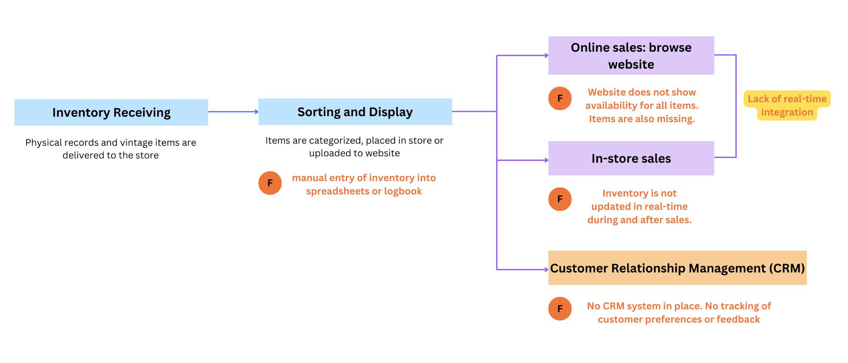
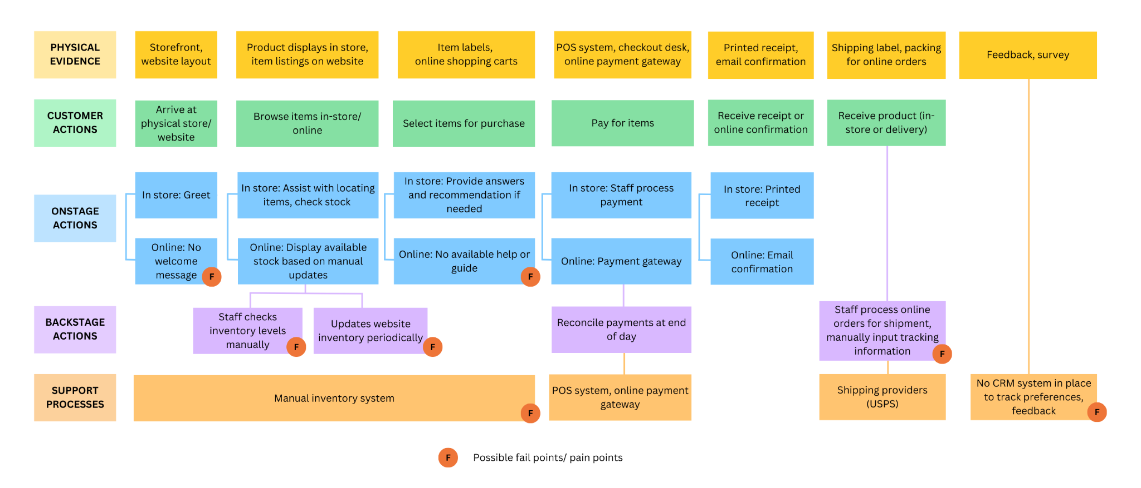
Comprehensive service blueprint based on the customer’s perspective:

Project Scope and Constraints:

Scope of Analysis:
- Implement a real-time inventory tracking and point-of-sale (POS) system for all products, with a focus on vintage stock and other items that are currently displayed online but unavailable in store.
- Ensure that all vintage items are accurately listed on the website, accompanied by clear photos and detailed product descriptions to enhance customer transparency.
- Introduce a Customer Relationship Management (CRM) system to capture insights about customer preferences, purchase patterns, and order frequency. Utilize this data to inform targeted advertising, improve marketing strategies, and strengthen community engagement.
Constraints:
- As a small family-owned business, ABC Vintage Store operates with limited financial and human resources compared to larger corporations.
- Staff often prioritize essential day-to-day operations over ongoing digital updates, making frequent inventory adjustments challenging.
- The transition to a modern inventory system may involve training time, overtime costs, and temporary disruptions during the implementation phase.

